McGill University

Architecture and Design Specification

Team 6: Amlekar R, Aydede E, Gupta Y, Wright A

ECSE 321:Introduction to Software Engineering

Dr. Sinnig

2015/03/29

Revision History:

|  |  |  |  |
| --- | --- | --- | --- |
| **Date** | **Changes to Document** | **Version** | **Changes made by** |
| 2015/03/29 | Creation of Document | 1.0 | Team 6 |
|  |  |  |  |

Table of Contents

Introduction

Audience

Scope

See also

System Architecture

The Tower Defense game implements a layered, multitier, architectural strategy. This architecture is based off of the typical client-server three-tier architecture, which has a presentation layer, a domain logic layer, and a data storage layer. Since the game does not store or use much data, the third layer has been removed. The architecture is thus a two-layered architecture, comprised of a presentation layer, and a domain logic layer. Advantages of any n-tier architecture include being able to make changes to the program easily. The developer can change aspects of the presentation layer with minimally affecting the domain model layer.

The architectural set-up that the game implements is the Model-View-Controller set-up. Although this was only briefly mentioned in class, the teaching assistant Shabbir showed its usefulness, and taught the tutorial attendees how to implement it (through a simple snake game). The MVC layout is beneficial as it fits nicely into the two-tier architecture being used. The view component of the MVC fits into the presentation layer, whereas the models and controllers fit into the domain logic layer. Having one controller allows for high-cohesion and low coupling, as it is not necessary for all of the “models” to be coupled to one-another. Instead, the controller connects all of the models together, and displays it through the view. In our case, we have one Model-View-Controller for the map editor, and one for the game (although they reuse many of the same classes). We implement a slight alteration, which is that we add a “Helper” component to the controller, so it is better represented by the phrase Model-View-Controller-Helper.

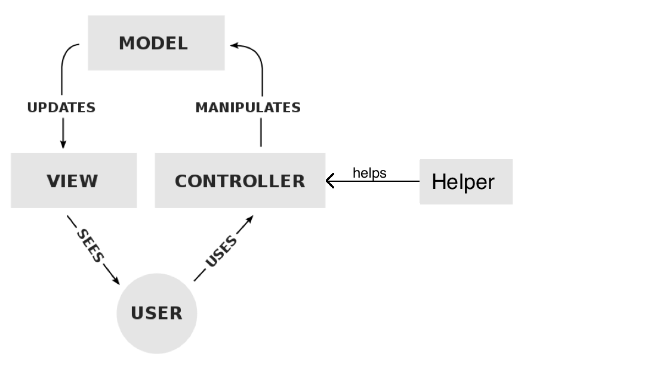

Architecture Diagram

Please note that the first diagram shown is the full architectural diagram (but with most methods and attributes omitted). Then there are zoomed-in diagrams of the presentation and business logic layers.

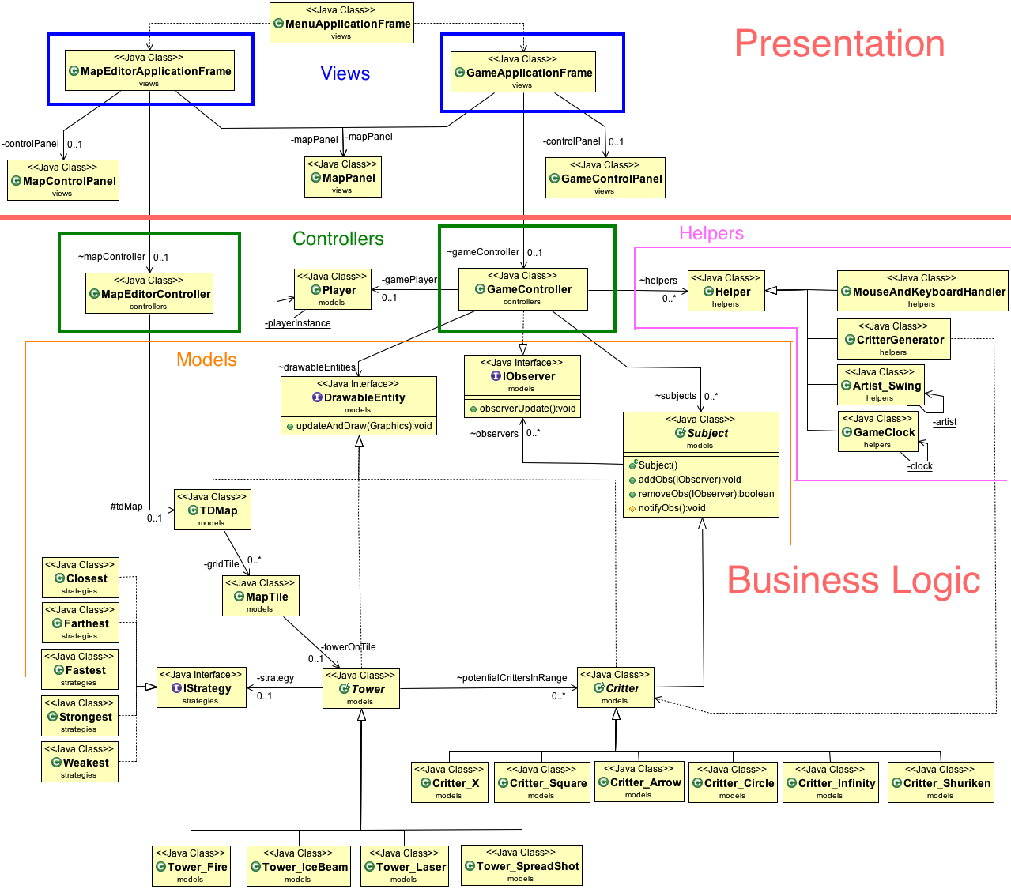

Although this first diagram may look complex, it actually demonstrates very low coupling, and good organization. Whereas without the MVCH layout, there may have been seemingly unnecessary connections, here all of the connections are easily understood. For example, there is a connection between the GameController and DrawableEntity. This interface is implemented by the Map, Tower, and Critter. Critters and Towers have their own subclasses. This is much cleaner than having all of these subclasses connect directly to the GameController.

Below is the presentation layer with all of the methods and attributes shown.

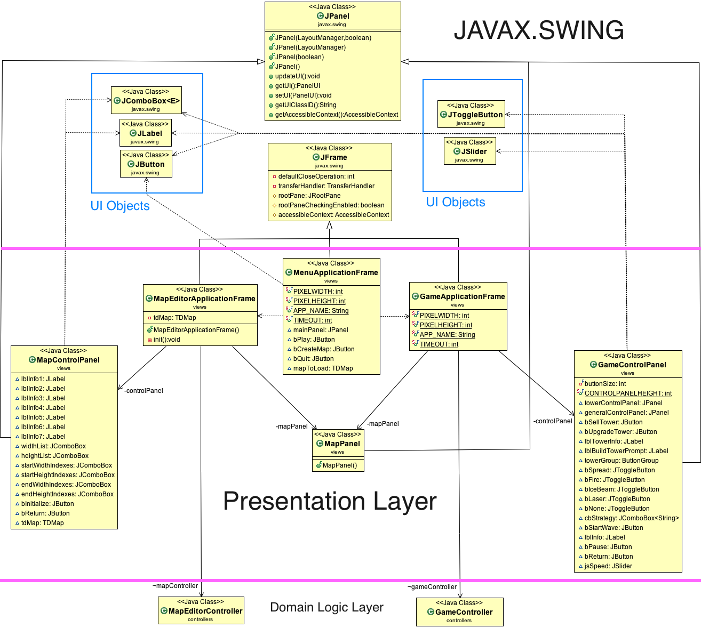

Java Swing was used to create the GUI that actually displayed all of the models. As such, the presentation layer (or the view in model-view-controller) extends heavily from Javax.Swing. The control panels for the game and for the map editor are both JPanels, the three application frames are JFrames, and all of the buttons or labels or comboboxes are from Swing as well.

Domain Logic Layer

1. Drawable Entities

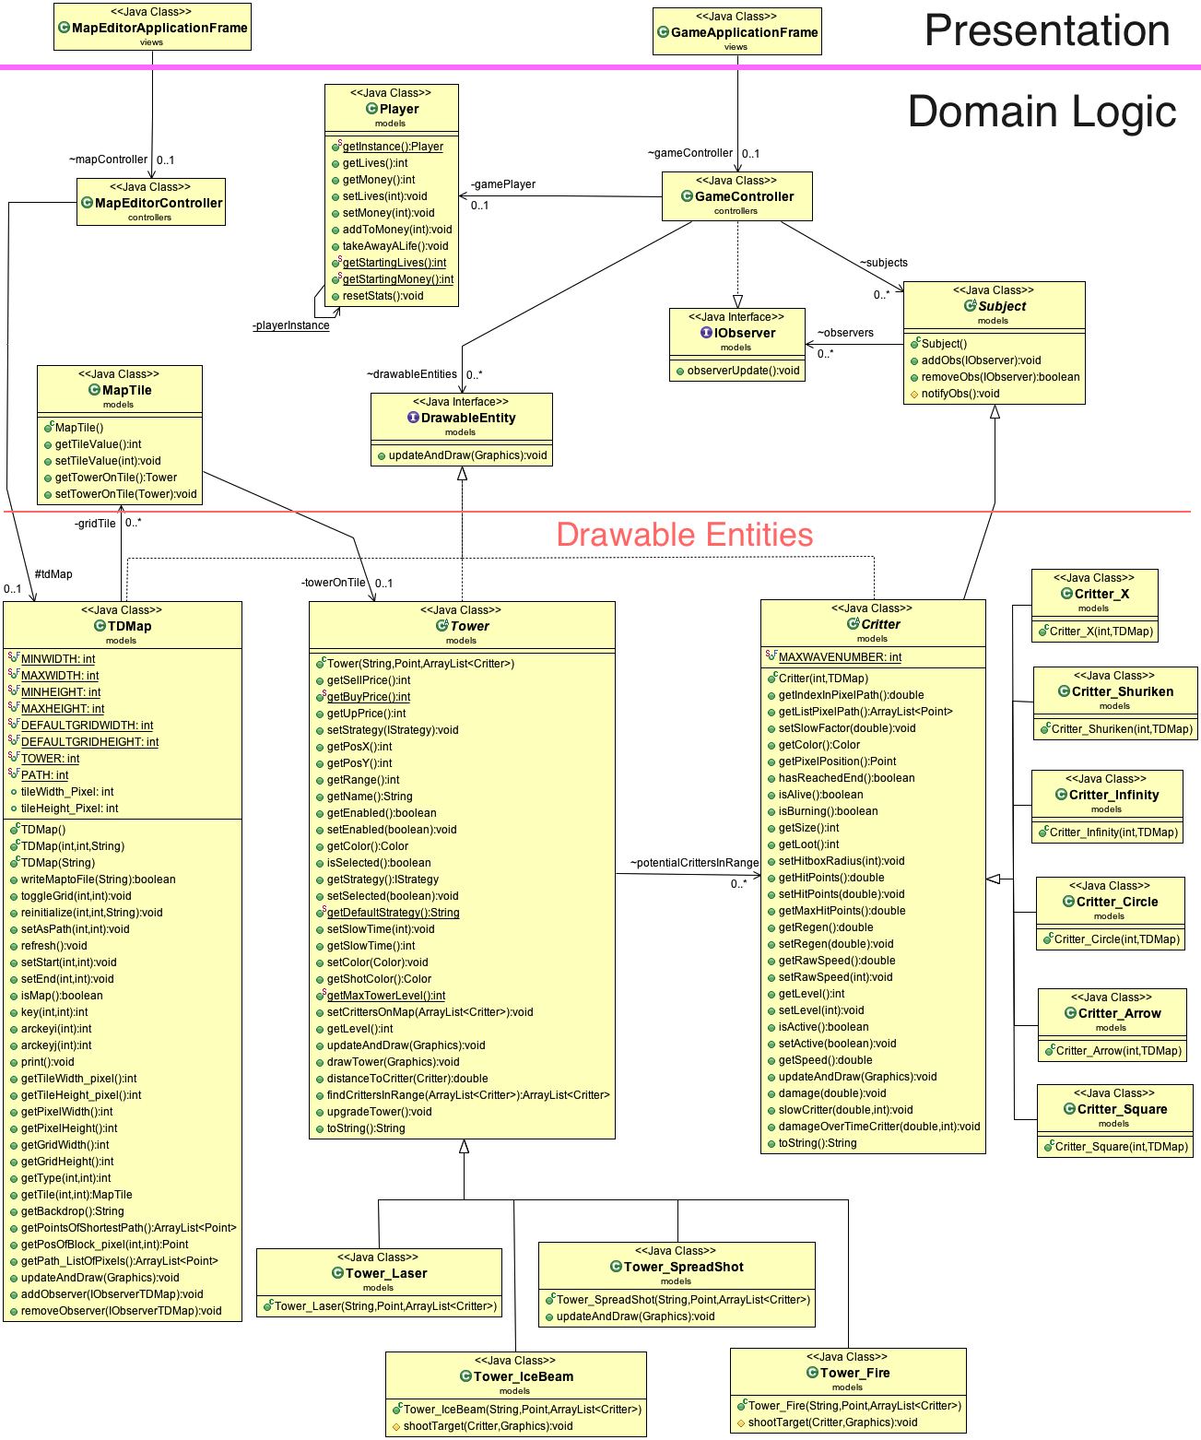

Note that the attributes of the Map, Tower, and Critter were not shown, as it created messy diagrams. In addition, it is redundant, considering that there are getter and setter methods that are shown.

1. Game Controllers and Helpers

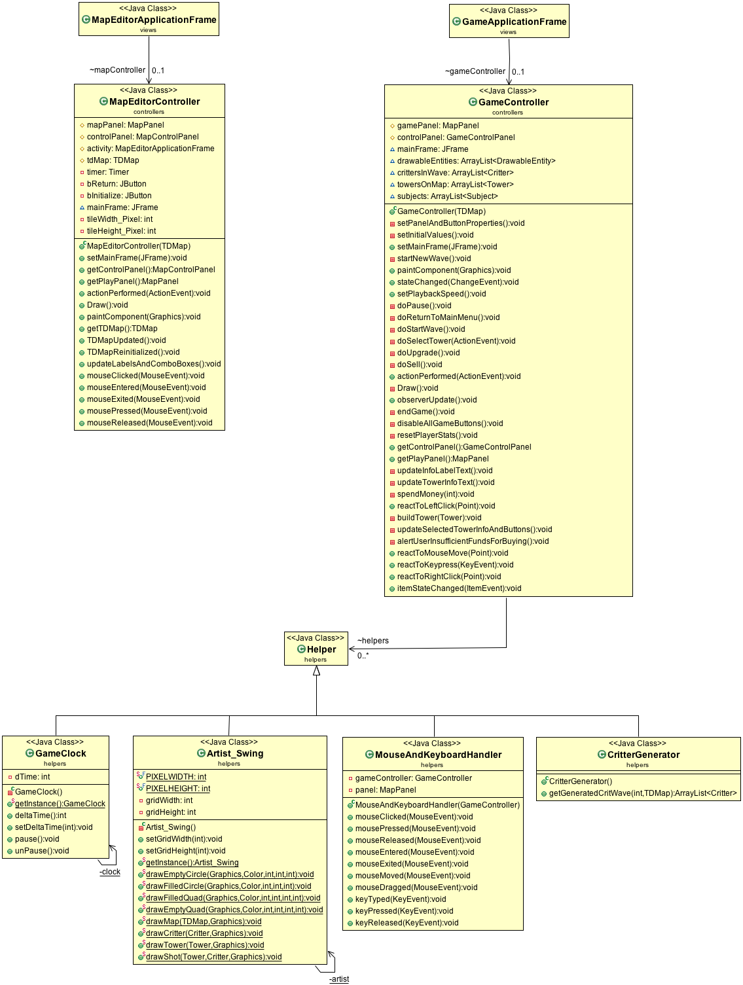

1. Strategies

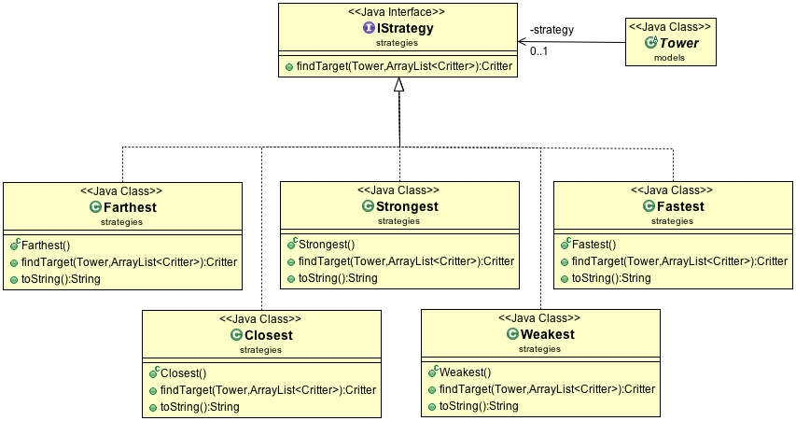

This design principle will be discussed below in the principles section.

**GRASP and Design Patterns:**

This section is dedicated to any programming problems or inefficiencies that were solved using the object oriented GRASP principles or design patterns learned in class or tutorials. Throughout the development of the Tower Defense game our team was able to identify and resolve general coding problems using the various GRASP principles. Some of the most prevalent principles used include:

* Indirection
* Information Expert
* High Cohesion
* Polymorphism

These principles allowed the code of the Tower Defense game to be considerably easier to understand and altered, if needed. In addition to the GRASP principles, our team implemented many design patterns as well. Among these design principles are:

* Subject Observer
* Strategy
* Singleton

Without these fundamental principles and patterns, the process of interpreting or editing existing code would be an unpleasant experience.

One result of using these principles and patterns is that it is relatively simple to add on to code, or to alter it. For example, our group initially decided to use the Light Weight Java Game Library (LWJGL) to display the game. Due to information expert and in a goal to create high cohesion, we had all of the methods for drawing in one class called Artist_LWJGL. When we decided to switch to Swing, we changed the class to Artist_Swing, and implemented the drawing with Swing. As there was very little coupling between the Drawable Entities (critters, towers, maps) and the artist, this change was painless.

**Principles**

**1) Principle Name:** Indirection Principle

Applying the indirection principle results in low coupling. It involves creating a middle class that acts between two other classes. We have applied the indirection principle throughout our code, and the helpers package contains classes that all are partially the result of the indirection principle. One example of the indirection principle is how we handle Critters being observed by the game controller.

**Sample Problem:** In the tower defense game, should the Critter class be directly responsible for adding removing or notifying observers?

**Sample Solution:** Instead of directly implementing the add remove and notify observer methods in Critter, we create a middle class called Subject that Critter extends. This subjet includes the list of IObservers and the methods for adding, removing, and notifying observers. This removes the coupling between observers and critters and allows the potential for other classes to be observed by having them extend the Subject class. It also means that if we wanted to change a property of a Subject, we simply change the Subject class.

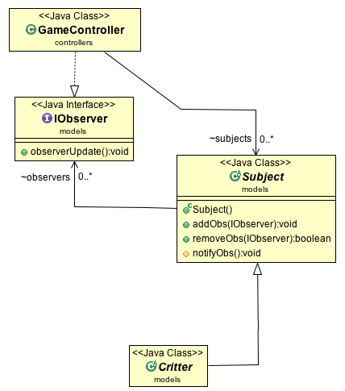

**2) Principle Name:** Information Expert

Information Expert pertains to what classes should know about other classes, and what they should be able to do. For instance, the Map does not need to know anything about the critters or the towers that are placed on it, but the Critters need to know about the Map’s path.

This principle is used on multiple occasions throughout our code to ensure that we do not have any upwards dependencies, and that classes know as little as they need to in order to still function correctly.

**Sample Problem:** In the Tower Defense Game which class should be responsible for knowing the information of how a Tower shoots a Critter?

**Sample Solution:** Towers and critters are the classes that are responsible for knowing their respective list of activities. The tower and critter instances are their own respective information experts. This means that when a Tower shoots a Critter, it does not directly affect the Critter’s attributes. This is because the Tower does not know about the Critter. Instead, the Tower shoots a critter, which results in triggering a damage method in the Critter. The Critter then handles this damage accordingly.

**3) Principle Name:** High Cohesion

**Problem:**

**Solution:**

(Optional Diagram)

**4) Principle Name:** Polymorphism

Polymorphism is when classes may have variations in their behavior based on their type, even if they all extend the same superclass.

**Sample Problem:** In the Tower Defense game how are Towers of nearly identical attributes yet varying attribute values and slightly different methods handled?

**Solution:** The Tower Defense game requires the creation or use of different types of Towers. These towers will have almost identical variables and methods, but they need to have slight differences. For instance, a fire tower must act like all of the other towers, but it must also be able to set Critters on fire, and damage them over time. This is when the principle of polymorphism is applied. With the implementation of a Tower superclass, every Tower type does not need to be referenced individually and the creation of additional Tower types is simplified since all Towers inherit attributes from the superclass. Additionally, towers can be created that have slightly different methods (like the setting on fire).

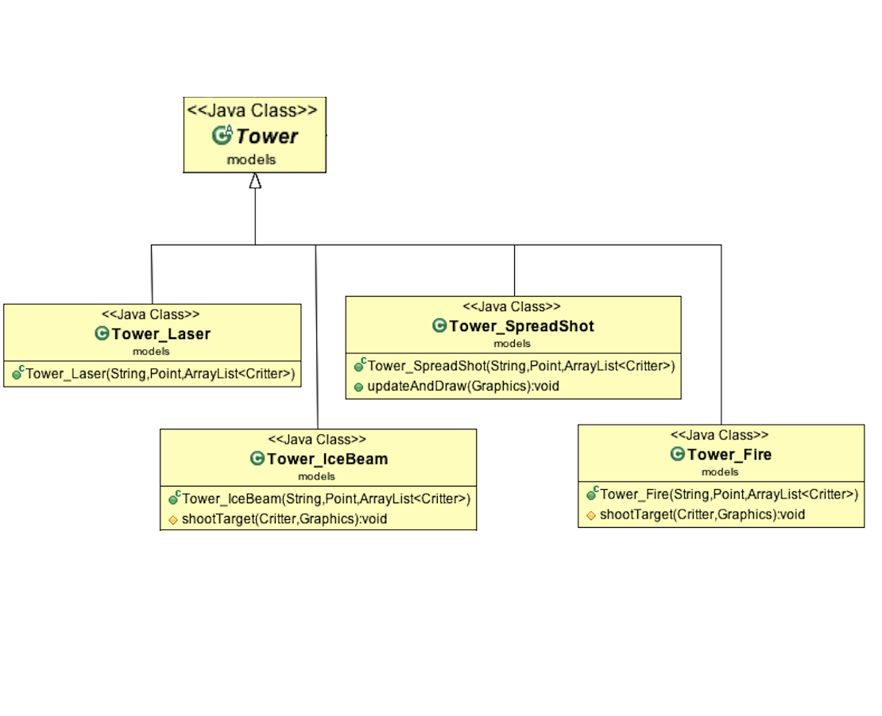

One can see that the spread-shot tower, the fire tower, and the ice beam tower all have “extra” methods that override some of the standard Tower methods. This allows them to shoot more than one critter, apply damage over time, and slow critters, respectively.

**5) Principle Name:** Creator

The Creator principle decides which classes are responsible for creating other classes. For instance, it would not be appropriate for the Tower class to be responsible for the creation of the Map, or even vice versa.

**Sample Problem:** In the tower defense game, who should be responsible for creating instances of the critter class?

**Solution:** There is a specific class for creating critters, called the Critter Generator. This class is the only class that is allowed to instantiate critters at runtime. The game controller is the class that is responsible for creating the generator (and is its Creator), and the generator creates the Critters. One reason why this is helpful is so that the creation of classes happens in a minimum amount of places. For instance, the creation of critters only happens in the generator, so if we want to change what critters show up, we just change the generator class. Note that having a generator class rather than generating them in the game controller directly is another instance of the indirection principle being applied.

**6) Principle Name:** Controller

**Problem:** In the tower defense game, what class should be responsible for mouse and keyboard input events?

**Solution:** There is a dedicated class for handling all mouse related input events named MouseAndKeyboardHandler. This class is used by the GameController, in the business logic layer, and thus handles input to the GameApplicationFrame and GameControlPanel in the presentation layer. Allowing all input related events to be handled by a controller class has allowed the implementation of input related events in the presentation layer without any downward dependencies. This is also an example of the indirection principle (having a separate class to handle these inputs over using the GameController directly).

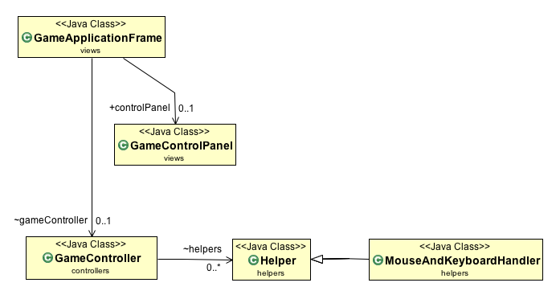

**Design Patterns**

**1) Pattern name:** Singleton

**Problem:** In the tower defense game how do we ensure that we create one (and only one) instance of the Player, Artist_Swing, and GameClock class while still letting these classes communicate and interact with other classes?

**Solution:** We apply the Singleton pattern, which ensures that there is only ever one instance of these classes. This instance is created when the program starts (via a private constructor), and can only be accesses through the public getInstance() method.

**i) Artist_Swing:**

It is crucial that the Artist_Swing has only one instance of itself because we need to access it from any class that implements DrawableEntity (TDMap, Critter, and Tower). We do not want to create a different artist for each one, and have to pass in information about the map each time. Instead, we get the instance in our GameController, and pass in the information there. Following this, we can easily get that instance from any other class (TDMap, Critter, or Tower) and use its methods. This demonstrates the power of this pattern.

**ii) Player:**

It is important that the Singleton pattern is applied to the Player class since there should only be one player who can be created. This cannot be a static class because it needs to have variables (lives and money) that can be altered.

**iii) Game Clock:**

The Game Clock is another class that relies heavily on the Singleton pattern. It is similar to the Artist_Swing class, as it too needs to be called from any object that is time-dependent (Critter and Tower), but also from the controller. Without the Singleton pattern, there could be many instances of the clock, and one would have to alter each clock if he/she needed the time to be synced. With the Singleton pattern, when the rate of ticking is altered in the game controller, the Critters and Towers are immediately affected. This allows for cool features like the pause button (calling the Game Clock instance’s pause()) method, and speeding up the wave (calling the Game Clock instance’s setDeltaTime()) method.

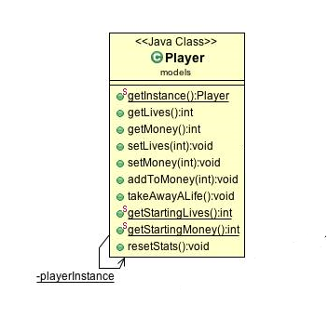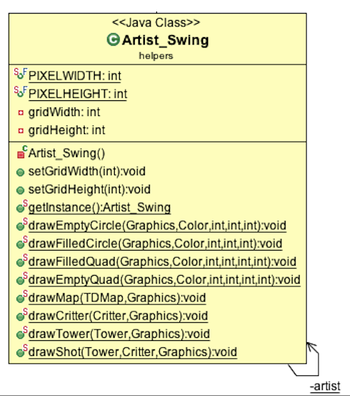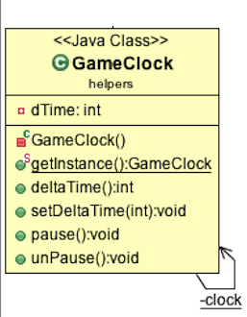

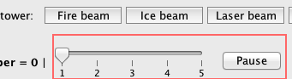

Figure 1 - The UI for changing the speed of the program

**2) Pattern name:** Subject Observer

**Problem:** In the tower defense game, how do we ensure that the Game Controller is updated every time an important change, like reaching the end or dying, occurs in the critter class?

**Solution:** The implementation of the IObserver interface and the subject class allow the gameController to be informed every time a critter moves or becomes damaged. The critter class extends the subject class and the gameController implements IObserever thus acting as an observer for critters.

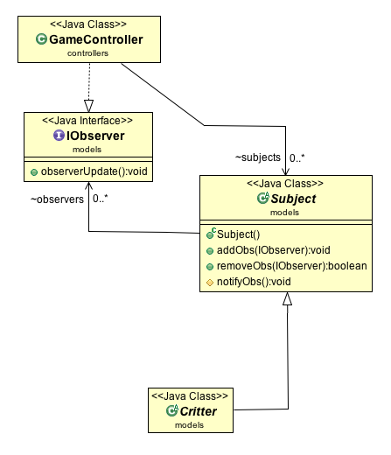

**3) Pattern name:** Strategy

**Problem:** In the tower defense game who is responsible for the various strategies that can be applied to the tower class resulting in a change in targeting patterns?

**Solution:** The interface IStrategy is responsible for all strategies used by the tower. The strategy classes themselves, each with different targeting patterns, implement the strategy interface.

